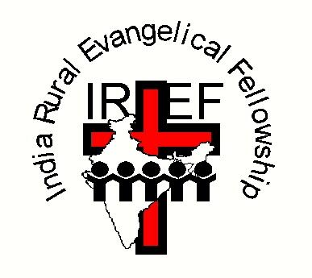
The India Rural Evangelical Fellowship is an indigenous Indian movement working throughout the southern State of Andhra Pradesh, amongst some of the poorest people in the world. It was founded in 1950 by Prasada Rao Rebba, a former teacher. Here are two examples of the kind of children IREF seeks to help.

IREF(UK) is a Recognised Scottish Charity, number SC033100
Copies of IREF (UK)'s annual accounts are available on request.

For further details, contact
Chairman of IREF(UK): Revd David Hunt,
Address: c/o 16 Wollaton Road, Ferndown, Dorset BH22 8QR
Telephone: 01202 929184
E-mail: revdavidrghunt@gmail.com

Websites: www.iref.co.uk and www.irefusa.org

Amazingly, 66p a day is all that it costs to help house, clothe, feed, and educate a child in India through the India Rural Evangelical Fellowship (IREF).

IREF currently cares for over 1500 children and young people. Many come from backgrounds of extreme poverty; their parents are often migrant agricultural workers eking out a subsistence living. Some of the children have tragically been abandoned by their parents, or abused, or rescued from human trafficking; about 30% are without a mother or father.

IREF provides them with hope by welcoming them into its Lydia’s Children’s Home, named after the wife of IREF’s founder, Prasada Rao. They launched their first Children’s Home in the 1980s when Lydia began home-schooling five children who had been left homeless in the wake of a devastating cyclone. For many of the children currently in IREF’s Children’s Home, it is the first time they have felt real peace and security.

Their physical, educational, emotional and spiritual needs are provided for in a loving, caring, Christian environment. The children not only hear about the love that Jesus Christ has for each one of them; they experience it on a daily basis through their committed carers and teachers.

How you can help: if you sponsor a child, you will be provided with a brief profile and photograph of the child, and will be able to correspond with him/her on a regular basis by post or e-mail. IREF employs Telegu/English translators for this specific purpose.

Who are the children needing your help?
Read on to find out more.
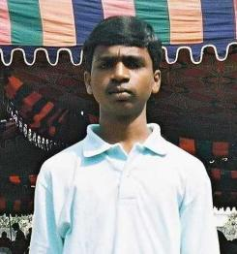
Ravi Kumar Nathala is one of five children. His parents became Christians through one of IREF's village crusades. They worked as labourers earning only £5 a month. Ravi was cared for by IREF from the age of seven. He made excellent progress at IREF’s John’s Elementary and High School, and went on to attend IREF’s Degree College. He is now working in the catering industry.

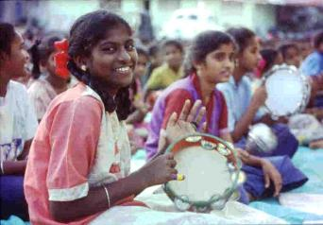
Lakshmi Arevarapu came from a Hindu background. She is one of four children. Her parents looked for seasonal work, digging irrigation ditches. They earned less than £4 per month as they travelled from village to village in search of work. This made it difficult for them to provide their children with continuity, as far as their schooling was concerned. They had inadequate money to feed or clothe their children because of their poverty. Yet Lakshmi was a smart girl and keen to learn. She benefited greatly from the education IREF was able to provide for her.

If you are able to help sponsor a child, please complete the Sponsorship Form opposite. All the money you give will be forwarded direct to India. Copies of IREF (UK)'s annual accounts are available on request.

IREF (UK) CHILD SPONSORSHIP FORM
(Please complete the form by ticking boxes as appropriate)

WHO ?
I would like to sponsor a boy ٱ a girl ٱ

HOW MUCH ?

Please insert figure: £ .............. per month/quarter/year

Suggested minimum amount per child:
£20 per month; £60 per quarter; £240 per annum

I would like my donations to benefit from Gift Aid ٱ

Your name: ...........................................................................................

Your address: ...........................................................................................

………...................................................................................

Your telephone: .......................................................................................

Your e-mail: ………..................................................................................

When completed, please return this form to
Honorary Treasurer: Mr Stewart J Shaw
Address: 62 Holmhead Road, Cumnock, KA18 1UA Scotland
Telephone: 01290 420708 (home)
E-mail: stewartjshaw@me.com

