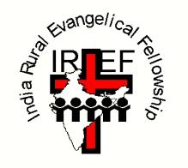
IREF is an indigenous Indian mission operating in the Telegu-speaking state of Andhra Pradesh. It was founded in 1950 by a former teacher, Prasada Rao. Over the past decades, IREF has gained an excellent reputation for providing high quality education for the rural poor of India.

IREF currently runs two residential schools, one of them in a Tribal Colony area. IREF’s schools and colleges provide much needed education for around 2,000 children and young people.

The largest school is in the town of Repalle, which is also home to
- IREF’s Junior College, for 16-18 year olds;
- IREF’s Degree College, offering Master’s degrees as well as a variety of BA and BSc courses for its 600 students;
- IREF’s Teacher Training College, offering a two-year BEd qualification;
- IREF’s Nurses’ College, provides a four-year degree course in nursing for female students;
- IREF’s Industrial Training Institute providing training in practical skills for 100 apprentices;
- Scope for further expansion in Repalle is limited, so IREF has pioneering several Child Development Centres in villages where IREF already has its own church building. IREF’s CDC’s enhance the education that a child receives through its government run school, by providing additional free tuition.

All IREF’s school and educational establishments are open to children and young people of all backgrounds and religions. However, they appeal most to the poorest sectors of Indian society, who have no other opportunities for self-improvement.
IREF(UK) is a Recognised Scottish Charity, number SC033100.
For further details, consult our website www.iref.co.uk
or use the contact details on the sponsorship form.

AN INVITATION TO

for some of India’s poorest children

From a mud-hut to a medical school – could you help someone’s dream come true?

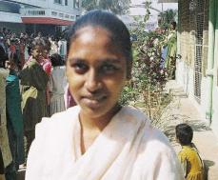
Jyothi wanted to become a doctor; but she came from one of the poorest regions of India. Her parents earned their living by digging irrigation ditches amongst the many rice fields in the coastal area of Andhra Pradesh known as ‘the rice bowl of India’, near where the River Krishna flows into the Bay of Bengal.

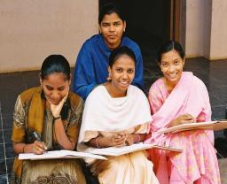
But thanks to the high quality education Jyothi received through the India Rural Evangelical Fellowship, she may have a chance to fulfil her dream. She was given a place at IREF’s John’s School in Repalle when she was seven years old, and then moved on to IREF’s Junior College to study for A-level type exams. Her goal was to be accepted for IREF’s Degree College, to take one of their three-year science courses, and then apply for a place at one of India’s medical schools. From her mud-hut to a medical school would be a dream come true for Jyothi!

Jyothi’s story could be repeated many times over. IREF educates around 600 children in its main school (shown below). The building is also the home of IREF’s Junior College for over 200 students. About 600 students study at IREF’s Degree College (shown opposite). IREF also trains teachers and nurses through two further colleges.
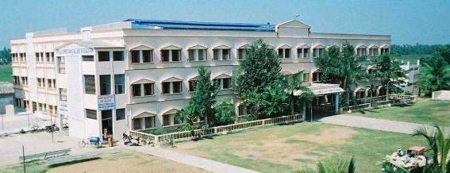
Since IREF founded its first school in 1984, tens of thousands of children and young people from some of the poorest backgrounds in India have benefited from IREF’s excellent education programme.
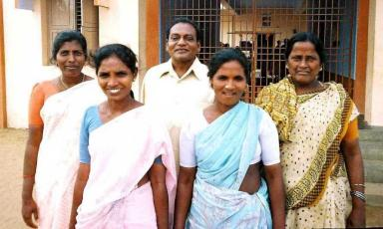

But none of this is possible without the dedicated skill of IREF’s many teachers.

This is where we can play our part
in helping people’s dreams come true.

For less than £1 a day, you could help sponsor one of IREF’s teachers!

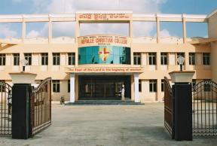
Through our Sponsor a Teacher scheme, you could have the privilege of sponsoring a primary school teacher, a secondary school teacher, a Tribal Colony teacher, a Child Development Centre teacher, a Junior College tutor, a Degree College lecturer, a Teacher Training College tutor, or a Nursing instructor! As a sponsor, you would be supplied with a photograph of your sponsored teacher and some brief biographical details. You would be able to correspond with your sponsored teacher, by post or e-mail.

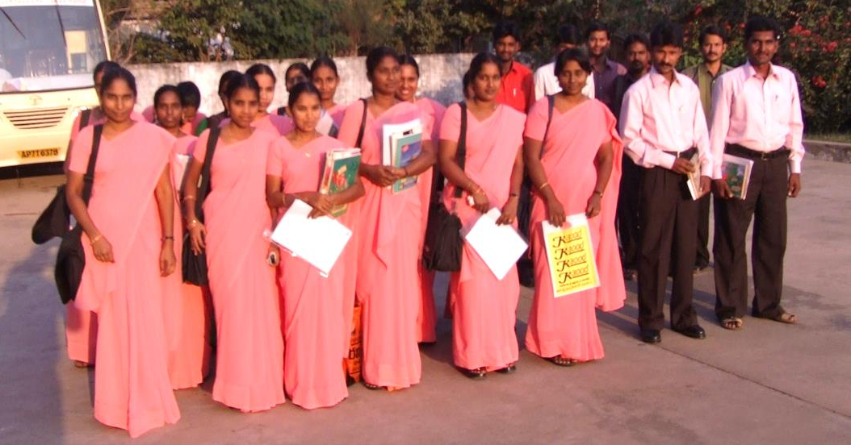
Some IREF Trainee Teachers

If you would like to help support one of IREF’s teachers,
please complete the sponsorship form.

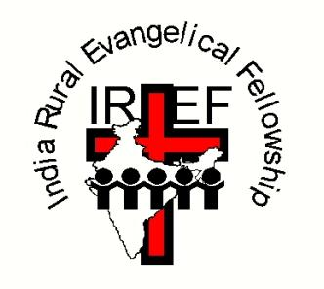
IREF
TEACHER SPONSORSHIP FORM

WHO ?
I would like to sponsor (please tick one or more boxes):

- a Primary School teacher
- a Tribal Colony teacher
- a Child Development Centre teacher
- a Secondary School teacher
- a Junior College tutor
- a Degree College lecturer
- a Teacher Training College tutor
- a Nursing instructor

If possible, I would like to be linked with someone who
teaches ……………………………. [specify preferred subject(s)]:

I would like to sponsor a male ٱ a female ٱ 

HOW MUCH ?

Please insert figure: £ .............. per month/quarter/year

Suggested minimum amount per teacher:
£25 per month; £75 per quarter; £300 per annum

I would like my donations to benefit from Gift Aid ٱ

Your name: ...........................................................................................

Your address: ...........................................................................................

………...................................................................................

Your telephone:
.......................................................................................

Your e-mail: ………..................................................................................

When completed, please return this form to
Honorary Treasurer: Mr Stewart J Shaw
Address: 62 Holmhead Road, Cumnock, KA18 1UA Scotland
Telephone: 01290 420708 (home)
E-mail: stewartjshaw@me.com

IREF(UK) is a Recognised Scottish Charity, number SC033100
Copies of IREF (UK)'s annual accounts are available on request.

For further details, contact
Chairman of IREF(UK): Revd David Hunt,
Address: c/o 16 Wollaton Road, Ferndown, Dorset
BH22 8QR
Telephone: 01202 929184
E-mail: revdavidrghunt@gmail.com

Websites:
www.iref.co.uk; www.irefusa.org;
www.rccollegeofedu.com; repallechristiancollege.org

