When completed, please return this form to
Honorary Treasurer: Mr Stewart J Shaw
Address: 62 Holmhead Road, Cumnock, KA18 1UA Scotland
Telephone: 01290 420708 (home)
E-mail: stewartjshaw@me.com

IREF(UK) is a Recognised Scottish Charity, number SC033100
Copies of IREF (UK)'s annual accounts are available on request.

For further details, contact
Chairman of IREF(UK): Revd David Hunt,
Address: c/o 16 Wollaton Road, Ferndown, Dorset
BH22 8QR
Telephone: 01202 929184
E-mail: revdavidrghunt@gmail.com

Websites:
www.iref.co.uk; www.irefusa.org;
www.rccollegeofedu.com; repallechristiancollege.org

All IREF’s school and educational establishments are open to children and young people of all backgrounds and religions. However, they appeal most to the poorest sectors of Indian society, who have no other opportunities for self-improvement.
IREF(UK) is a Recognised Scottish Charity, number SC033100.
For further details, consult our website www.iref.co.uk
or use the contact details on the sponsorship form.

to provide healthcare for India’s rural poor

Meet Divya. She comes from a lowly background; her parents work in rice fields, earning only £2 per day. Divya studied hard to gain a college education and is now the best educated member of her family. She attended IREF’s Junior College for two years before going on to complete a four-year nursing degree through IREF’s Nursing College. She is now employed as a full-time member of IREF’s staff to provide medical care for the many children and young people on IREF’s Repalle campus.

For less than £1 a day, you could help sponsor a trainee nurse!

In 1996, IREF introduced a basic 18-month Health Care Course for up to 20 female students a year through its Health Workers Training Institute. More recently, IREF has been running a four-year BSc Course in nursing through its Repalle Christian College of Nursing.

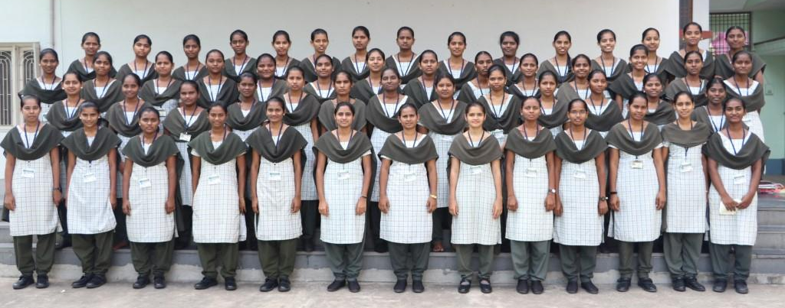
some of IREF’s nursing students

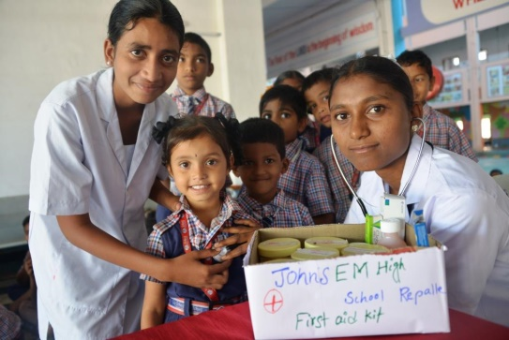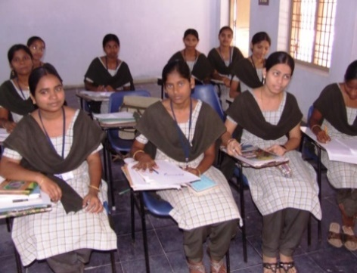
training involves both classroom learning and practical work

IREF’s nurses participate in Community Wellness and Awareness programmes during their time at IREF’s Nursing school. They provide essential medical services to local towns and villages as part of the clinical requirements of their studies. In addition, they assist with medical clinics run by healthcare professionals from the US and UK.

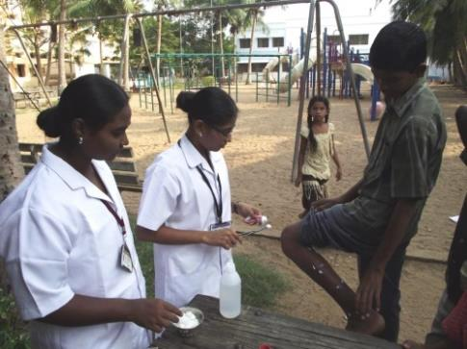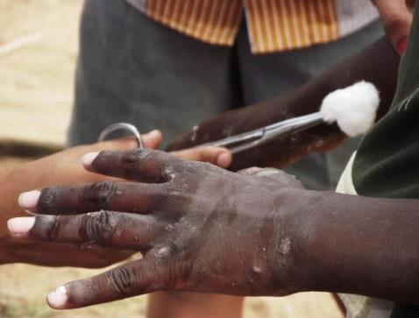
Student nurses helping to treat scabies on IREF’s campus

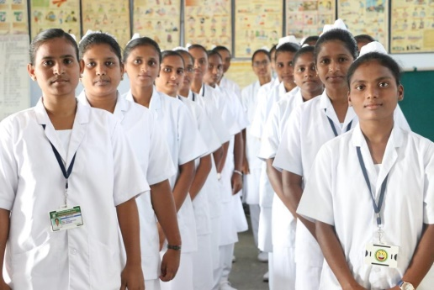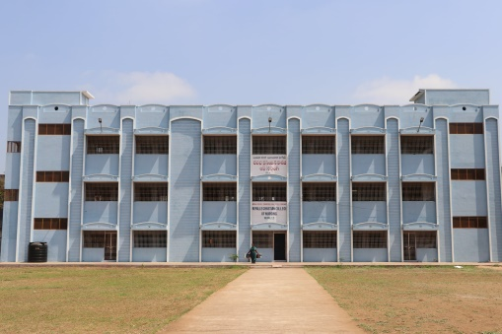
IREF’s nurses in uniform and their Nursing College Building

If you would like to help support one of IREF’s trainee nurses,
please complete the sponsorship form.
IREF
TRAINEE NURSES SPONSORSHIP FORM

WHOM?

- I would like to help to sponsor a Nursing Degree Student

- I would like to help to co-sponsor a Nursing Degree Student

HOW MUCH ?

Please insert figure: £ .............. per month/quarter/year

Suggested minimum amount per student nurse:
£25 per month; £75 per quarter; £300 per annum
[half this level for co-sponsorship]

- I would like my donations to benefit from Gift Aid

YOUR CONTACT DETAILS

Your name: ...........................................................................................

Your address: ...........................................................................................

………...................................................................................

Your telephone: .....................................................................................

Your e-mail: ………..................................................................................

