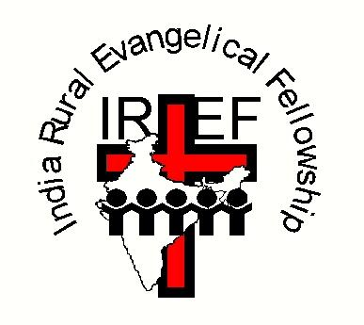
IREF(UK) is a Recognised Scottish Charity, number SC033100
Copies of IREF (UK)'s annual accounts are available on request.

For further details, contact
Chairman of IREF(UK): Revd David Hunt,
Address: c/o 16 Wollaton Road, Ferndown, Dorset BH22 8QR
Telephone: 01202 929184
E-mail: revdavidrghunt@gmail.com
Websites: www.iref.co.uk and www.irefusa.org

The India Rural Evangelical Fellowship is an indigenous Indian mission working in one of India's most populous states, Andhra Pradesh. It was founded over 70 years ago by a former teacher, Prasada Rao Rebba. It currently supports over 200 national evangelists, both men and women, working in over 300 towns and villages. Yet it is estimated that there are 17still 5,000 of Andhra Pradesh's 30,000 villages with no known Christian witness. In many of these villages, the name of Jesus is still completely unknown.

For just over £1.30 a day, you can support one of IREF’s evangelists and his/her family. Only a small number of IREF's evangelists are currently being sponsored; but they pool their income in a spirit of Christian love and fellowship. So, there is an urgent need for more sponsors to come forward to have the privilege of supporting the spread of the Gospel in this way.
- All the money you are able to give will be forwarded direct to India.

On their visits to Andhra Pradesh, teams of UK Bible teachers and medical personnel regular have the joy of seeing thousands of people respond to the message of God's love as they share the good news of Jesus. IREF evangelists are responsible for ensuring that these new Christians are properly taught and well-grounded in the faith. So, there is such an urgent need to increase the number of men and women dedicated to reaping and preserving the harvest that God is currently granting to this part of his world.

Read on to find out more about the sort of people you can support.
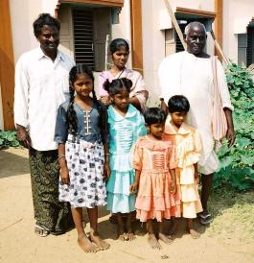
Khasim Shaik was brought up in a Muslim family, but heard about Jesus through an IREF evangelist. He gave his life to Jesus Christ in 1977 and four years later started work as an IREF evangelist. He chose to work amongst Muslims in his own village and two others.

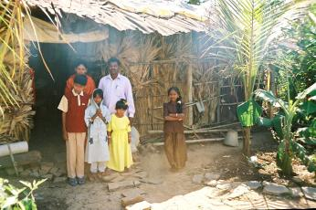
Vidhya Saga Ambati was six years old when he was taken into IREF's children's home in Repalle; his father had fallen ill from tuberculosis. There he experienced Christ's love and his life was changed. After graduating from IREF's High School, Vidhya registered at the School of Evangelism to receive training to become an ambassador for Christ.
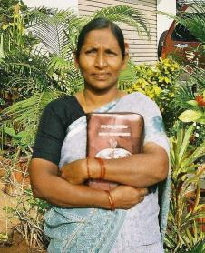
Lalitha Kumari is a female evangelist (Bible Lady). Culturally, it is inappropriate for men to evangelise women. Lalitha was brought up in an idol-worshipping Hindu family. She was converted to Christ in 1975, and seven years later began working as an IREF evangelist.

Can you spare £1.30 a day to help these and others spread the good news of Jesus Christ? If so, please complete the Sponsorship Form opposite.
IREF (UK) EVANGELIST SPONSORSHIP FORM
(Please complete the form by ticking boxes as appropriate)

WHO ?
I would like to sponsor: a male evangelist ٱ a Bible Lady ٱ 

HOW MUCH ?

Please insert figure: £ .............. per month/quarter/year

Suggested minimum amount per evangelist:
£40 per month; £120 per quarter; £480 per annum

I would like my donations to benefit from Gift Aid ٱ

Your name: ...........................................................................................

Your address: ...........................................................................................

………...................................................................................

Your telephone: .......................................................................................

Your e-mail: ………..................................................................................

When completed, please return this form to
Honorary Treasurer: Mr Stewart J Shaw
Address: 62 Holmhead Road, Cumnock, KA18 1UA Scotland
Telephone: 01290 420708 (home)
E-mail: stewartjshaw@me.com

