This is how you can help.
Each CDC child is provided with a school uniform, textbooks, workbooks, a nourishing meal each day, and basic health care.

- You could co-sponsor a child for just over £1 per week!
We recognise that not everyone can afford the full cost of sponsoring a child. So we have come up with the new idea of co-sponsorship for the children in IREF’s care.

- For just £5 a month, you could sponsor a child alongside another such sponsor, whom we would find. Each sponsor will receive a profile of their sponsored child, consisting of a photograph and brief biographical details.

- For £10 a month, you could be a child’s sole sponsor.

Donations can be Gift Aided.

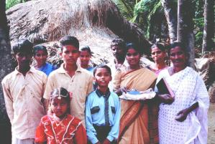
Full details of IREF’s CDC project and their many other activities are available on request.

For further information, contact
Chairman of IREF(UK): Revd David Hunt,
Address: c/o 16 Wollaton Road, Ferndown, Dorset BH22 8QR
Telephone: 01202 929184
E-mail: revdavidrghunt@gmail.com
Websites: www.iref.co.uk and www.irefusa.org

If you would like to make a real difference
to some of the poorest children in rural India,
please complete the enclosed sponsorship form.

AN INVITATION TO

to some of the poorest children in India
for as little as about £1 a week

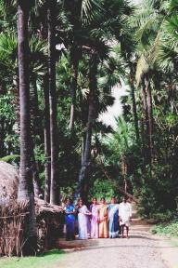
Ullipalem is a small village in rural India, not far from where the River Krishna empties its waters into the Bay of Bengal. The village is surrounded by rice fields. This is where many of the villagers work to eke out their subsistence living. Most village families live in a simple, single-room mud hut, with a mud floor and thatched roof.

But appearances can be deceptive; though poor, these villagers aren’t lacking in intelligence. It’s simply that they have never had a good opportunity to develop their potential to the full.

This is where you can help!
Read on to find out how …
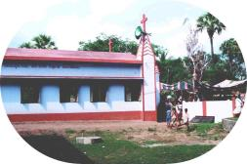
In 2002, a Church Building was constructed in the village. It was paid for by Airdrie Baptist Church in Scotland. The church building serves not only as a worship centre for the 100-strong congregation who meet in it each Sunday. It also serves as a cyclone shelter for the whole village community in stormy weather. In addition, the building is used each weekday for one of IREF’s Child Development Centres.

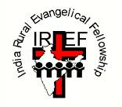
IREF is an indigenous Indian mission operating in the Telegu-speaking state of Andhra Pradesh. It was founded in 1950 by a former teacher, Prasada Rao. Over the decades, IREF has gained an excellent reputation for providing high quality education for the rural poor of India.

IREF currently runs two Residential Schools, one of them in a Tribal Colony area. Between them, the schools provide much needed education for about 600 children and young people.

IREF’s main school is in the town of Repalle, which is also home to
- IREF’s Junior College, for 16-18 year olds;
- IREF’s Degree College, offering Master’s degrees as well as a variety of BA and BSc courses for its 600 students;
- IREF’s Teacher Training College, offering a two-year BEd qualification; and
- IREF’s Nurses’ Training Institute, providing a one-year foundation course in public health and hygiene and a four-year degree course.
- IREF’s Industrial Training Institute offering practical skill-based courses

As scope for further expansion in Repalle is limited, IREF has pioneered several Child Development Centres in villages such as Ullipalem, where IREF already had a church building.

Many of the rural villages in Andhra Pradesh already have a government-run school, catering for children up to the age of 10. But the education most of them can offer is quite limited. They are normally staffed by only one teacher, who has the daunting task of trying to meet the educational needs of pupils across the entire primary level age-range.

IREF’s CDCs seek to enhance the education a child receives through its government-run school, by providing additional tuition after school hours (parents often have to work in the rice fields in the evenings and at weekends). Each CDC is staffed by at least two qualified teachers, who are able to offer one-to-one tuition where needed, as well as whole class lessons.

Health care and hygiene classes, physical and recreational activities, and a spiritual education programme are included in the curriculum for each child, alongside its academic syllabus.

Refreshments are provided for each child when he/she arrives at the centre; supper is provided at the end of each day’s tutoring session.

Each Sunday, the children are encouraged to attend IREF’s village church service, along with their parents, as part of the support that IREF seeks to offer to whole families; but there is no element of compulsion or coercion.

IREF’s CDCs are open to children of all backgrounds and religions. However, they appeal most to the poorest sectors of Indian society, who have no other opportunities for self-improvement.
SPONSORSHIP FORM
tick as appropriate

I would like to co-sponsor a CDC child at
- £5 a month
- £15 per quarter
- £60 per annum.

I would like to fully sponsor a CDC child at
- £10 a month
- £30 per quarter
- £120 per annum.

- I would like my contribution to benefit from Gift Aid.

Your name: ...........................................................................

Your address: ...........................................................................

..............................................................................

Your telephone: .....................................................................

Your e-mail: ...........................................................................

When completed, please return this form to
Honorary Treasurer: Mr Stewart J Shaw
Address: 62 Holmhead Road, Cumnock, KA18 1UA Scotland
Telephone: 01290 420708 (home)
E-mail: stewartjshaw@me.com

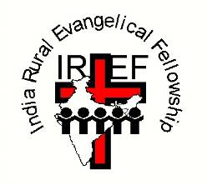
IREF(UK) is a Recognised Scottish Charity, number SC033100
Copies of IREF (UK)'s annual accounts are available on request.

For further details, contact
Chairman of IREF(UK): Revd David Hunt,
Address: c/o 16 Wollaton Road, Ferndown, Dorset BH22 8QR
Telephone: 01202 929184
E-mail: revdavidrghunt@gmail.com

Websites: www.iref.co.uk and www.irefusa.org

